**Conference Proceedings Paper Formatting Instructions NCETI-2025**

***(The formatting instructions are framed based on international conference proceedings guidelines)***

**TITLE PAGE**

The title page should include the name(s) of the author(s), a concise and informative title, the affiliation(s) (Institution, Department, City, State, Country), and an active email address of the corresponding author.

**Affiliation**

1Jane Dcoute, Department of Civil and Environmental Engineering, Research State University, P.O. Box 98765, City, ST 99999-1111; e-mail: imauthor@rsu.edu

2Guy Richard, Mail Stop LC 444, 2233 West 32nd Avenue, Township, ST 88888; e- mail: co.author@everco.com

**ABSTRACT**

Please find below the instructions to present your paper at NCETI-2025. The proceedings containing papers presented at this conference will be produced from the manuscripts received from authors. The abstract should consist of one paragraph of about 150-250 words. The abstract should present a concise statement of the scope, principal findings, and conclusions of the paper. Abstracts cannot include lists, tables, figures, display equations, footnotes, or references.

**INTRODUCTION**

An author’s central obligation is to present a concise account of his or her research, work, or project accompanied by an objective discussion of its significance. Submitted papers should contain detail and reference to public sources of information, so that the author’s peers are able to repeat the work or otherwise verify its accuracy.

The NCETI-2025requires that conference proceedings papers be original, unpublished work. Dual publication (publishing the same paper in multiple places without permission of the original publisher and agreement by the subsequent publisher) is a professional ethics violation and a legal problem. Only people who have significantly contributed to the research, project, or manuscript preparation should be listed as co-authors. The corresponding author will attest that any people named as co-authors have seen the final version of the paper and agreed to its submission for publication.

NCETI-2025conference proceedings will not publish abstract-only submissions or slide presentations in conference proceedings. Proceedings papers may not be published later as journal articles, unless the papers have been substantially revised to include new or additional material.

**REQUIREMENTS FOR SUBMITTING A PAPER**

**Submission Deadlines.** If your abstract has been accepted, please submit the final version of your paper by the deadline established by the NCETI-2025conference organizing committee or proceedings editor. Review your paper carefully before you submit the final version. Once a paper has been uploaded, reviewed by the author, and officially submitted, it is not possible to edit the document.

**Approvals** Before submitting a paper, authors must obtain approvals from such interested parties as the authors' employers, clients, project owners, and government agencies.

**Permissions.** Any materials that are not the original work of the authors of a proceedings paper must have the source identified at the end of a text extract or in a credit line immediately below the figure or table. The ***authors*** of each paper are responsible for securing permissions for non-original materials and must be able to provide the permission documents if requested by ICRACE-2022. The publisher of NCETI-2025reserves the right to eliminate from the published proceedings any figures or tables lacking appropriate permission and to make editorial changes as necessary.

**Copyright Transfer.** NCETI-2025conference board requires that authors or their agents assign copyright to NCETI-2025for all original content published by NCETI-2025conference proceedings. The author(s) warrant(s) that the above cited manuscript is the original work of the author(s) and has never been published in its present form. A declaration stating the following is required from the authors for copyright transfer.

* The undersigned author and all co-authors retain the right to revise, adapt, prepare derivative works, present orally, or distribute the work, provided that all such use is for the personal non-commercial benefit of the author(s) and is consistent with any prior contractual agreement between the undersigned and/or co-authors and their employer(s).
* No proprietary right other than copyright is claimed by NCETI-2025and its organizers.
* If the manuscript is not accepted for conference publication or is withdrawn by the author prior to publication (online or in print), this transfer will be null and void.

**MANUSCRIPT FORMATTING**

A proceedings paper consists of a title; an author by-line and affiliation(s); an abstract; the text with optional tables, figures, and mathematics; a conclusion; and references. Acknowledgments, appendixes, and notations are optional.

**Paper Length.** Thepaper should be typed in A4 format. The number of pages shall be not less than 4 and should not exceed 10 pages with single line spacing, inclusive of figures, diagrams, tables, references and appendices. English (UK) or (US) spelling is accepted. All the in-text references should be placed in chronological order (Ling 1856, Paul & Simon 1962).

**Point size and font.** Use 12 point type for text, captions, and author contact information. For type within figures or tables, the 12 point size is preferred. The NCETI-2025publication recommends selecting a font Times Roman. *Italics,* **bold,** and ***bold italics*** may be used; using only one “family” of typefaces yields the cleanest results.

**Headers and footers.** Do not put any information in the header. The only acceptable content in the footer is a single page number.

**Figures and tables.** All graphics (photos, line art, and tables) must be included electronically (embedded) within the document and centered. It should also fit within the margin settings. All photos and drawings should be of good quality (min. 300 dpi) with figure text and legends (character size > 1 mm) that are legible. Figures may be placed in the text or in a “gallery” at the end of the paper. Do not wrap text around the figure, even to save space. Landscape orientation is acceptable.

Illustrations should be numbered consecutively as they are presented (Figure 1, Figure 2, etc., and Table 1, Table 2, etc.). Each figure should be mentioned in the text or “called out” before it appears.

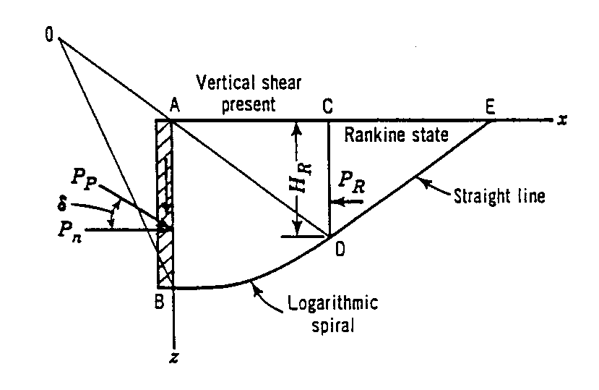

**Figure 1. Sample line art illustration.**

**Layout.** All text must be single-spaced. Page design should be consistent throughout the paper. Margins should be 1 inch (34 mm) on all sides, and all elements (text, figures, tables, captions) must fit within those margins. The paper should contain no more than four levels of headings. The following Table 1 gives a summary of all heading levels.

**Table 1. Table captions should be placed above the tables.**

|  |  |  |
| --- | --- | --- |
| Heading level | Example | Font size and style |
| Title (centered) | **Lecture Notes** | 14 point, bold |
| 1st-level heading | **1 Introduction** | 12 point, bold |
| 2nd-level heading | **2.1 Printing Area** | 12 point, bold |
| 3rd-level heading | ***2.1.1 Printing Area*** | 12 point, bold |
| 4th-level heading | *Lowest level heading* | 12 point, Italics |

**Mathematics.** All mathematics must be embedded in the text. Equations need to be numbered *only* if they are referred to more than once.

$y=\sqrt{b^{2}-4ac}$ (1)

**System of units.** NCETI-2025encourages the use of SI units.

**Author contact information.** A sample of author contact information is shown on the first page of these instructions. The following information may be provided for all authors of the paper: author’s full name; academic degrees or honorifics; professional licenses; professional bodies membership grade; current employment affiliation; mailing address; and e-mail address. Note that each author has one and only one note with contact information. Multiple authors with the same employment affiliation or mailing address must have separate notes.

**References.** All factual material that is not original with the author must be accompanied by a reference to its source NCETI-2025suggest APA reference format

**CONCLUSIONS**

NCETI-2025thank you for your efforts and looks forward to providing a record of this conference that will be useful to you and your colleagues for many years to come.

**REFERENCES**

ASCE (American Society of Civil Engineers). (2014*) Minimim Design Loads for Buildings and Other Structures*, Standard ASCE/SEI 7-10. Third printing. ASCE, Reston, VA.

Author, A., Author, B. and Author, C. (2018). *Title*. Journal Title, 130(8), 1272-1279.

Author, A. and Author, B. (Year). *Title*. Journal Title, 10.1061/(ASCE)ST.1943-541X.0001152, 04014185.

Author, A. and Author, B.: *Title of a proceedings paper*. In: Editor, F., Editor, S. (eds.) CONFERENCE 2016, LNCS, vol. 9999, pp. 1–13. Springer, Heidelberg (2016).

Author, F., Author, S., Author, T.: *Book title*. 2nd edn. Publisher, Location (1999).

Author, F.: *Contribution title*. In: 6th International Proceedings on Proceedings, pp. 1–2. Publisher, Location (2018).